

**Dispute Resolution**

The process of developing an Individual Development Plan (IDP):

* Makes sure the views, wishes and feelings of you and your child or young person are represented
* Helps to overcome concerns and prevent disagreements from arising

Early resolution of any disagreements is best for everyone and can help to avoid stress.

If you are unable to agree about decisions or provision it may be helpful to have independent, impartial help.

Dispute Resolution

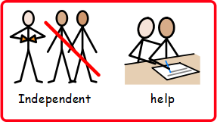



**Claire Gratton ALNCo**

**01633 647488**

**Mrs.gratton@wcp.schoolsedu.org.uk**

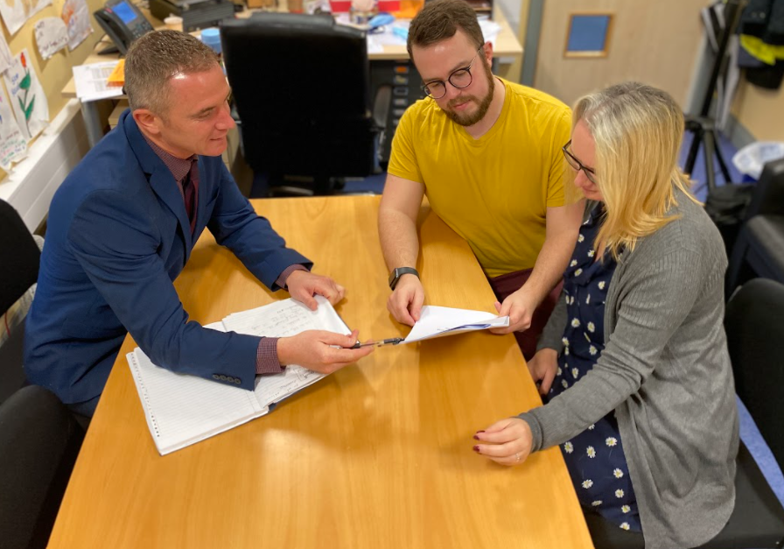

# Torfaen County Borough Council - My Council Services

**SNAP CYMRU**

Snap Cymru is our Independent Parent Partnership service, free to families and offers impartial, accurate information, advice and support to:

Help bring together all relevant parties;

Support the needs of the child and young person;

Help to achieve early and informal resolution of disagreements through discussion and agreement;

discuss the full range of options

SNAP Cymru is an all-Wales children’s charity working with families, young people and professionals in our area on issues regarding Additional Learning Needs and disabilities

The information and advice line is available

Monday – Friday

9.30 am – 4.30 pm.

www.snapcymru.org/help-for-families/

# 

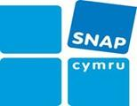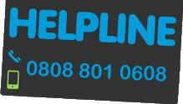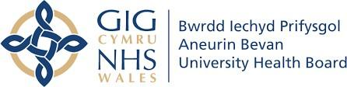

If your concerns or disagreements are to do with a Health service, the Local Authority and the Designated Clinical Education Lead Officer (DECLO) appointed by ABUHB will work together with the local authority, to try to find a solution. Or you can contact the Health Board directly

Information on Putting Things Right can be found at: http://www.wales.nhs.uk/ourservices/ publicaccountability/puttingthingsright

01495 745656